ANALYSIS OF ALTERNATIVES (AoA)

This Analysis of Alternatives will: (1) identify and evaluate various methods of obtaining needed goods and services, (2) determine which alternative is the most advantageous to the government, (3) document the value analysis, and (4) (For Economy Act Assisted Acquisitions,) attest that the work required to be performed is not an inherently governmental function.

To be completed by the USCG Program Manager or Requesting Unit Point of Contact:
1/c Cody Meyers

Requesting Agency: United States Coast Guard (USCG)

Project Description: The autonomous unmanned ariel vehicle (UAV) currently undergoing design has specific requirements for casualty response. In the event of a casualty, the vehicle must: 1.) slowly descend at a rate of less than 3 ft/s and 2.) remain positively buoyant for a minimum of 120 seconds in the event of a water landing. This AoA will assess multiple solutions to the buoyancy requirement in item 2 above.

Analysis of Alternative Solutions:

The requirement of remaining positively buoyant for 120 seconds is not necessarily a time requirement as stated. The difficulty in achieving this requirement does not lie in the time, but rather the capability to keep the drone floating without damaging any necessary components. The drone will have a weight of 3-4 lb. meaning that the floatation device must provide at least this in buoyant force. The flotation device must also not add an excessive amount of weight to the drone’s overall weight. If the drone weighs too much, the current motors/propellers may not be able to provide sufficient thrust to fly. No cost restrictions are anticipated for the implementation of this device; however, costs will still be considered in final decision. The flotation device must also not interfere with the UAV’s ability to land on another autonomous surface vessel. Finally, the flotation device must be located low enough on the drone platform to prevent electronic components from being submerged. In summary, the following solutions will be measured in terms of: buoyant force provided, weight added to system, cost.

USCG In-House Resources: No in-house resources are available for the proposed alternatives. However, the alternatives below may require mounting systems which can be fabricated using USCG owned 3-D printers.

Commercial Off the Shelf solutions:

- Water Strider Flotation System: The Water Strider system by Drone Floats is a commercially available attachment for the DJI drone platform. The system consists of four pods extending from the drone’s center to provide floatation in the same way a water strider insect does. The system can provide 3 kg (6.6 lb.) of buoyant force, weighs 0.26 kg (0.57 lb) and costs $119 retail. Since the system is not designed for the same drone platform as the current UAV, an additional mount would need to be created for attachment. The system is capable of riding low enough on the UAV to prevent electronic components from submerging.

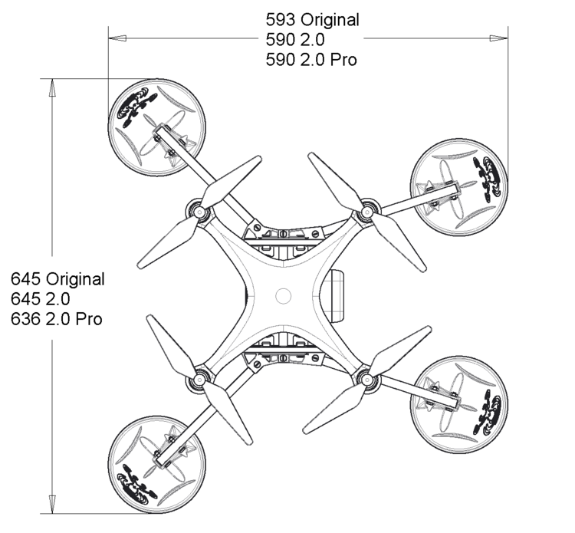
Figure 1. Water Strider Flotation System

- 350q Modeling Balloons: Utilizing the 350q modeling balloons as shown in Figure 2 and Ref [2], a simple outrigging design could be made to attach to the legs of the UAV. Ref [2] states that the balloons would create a combined 12 kg (26.5 lb) of buoyant force with a 3” diameter and 50” length. The proposed design would weigh ~0.08 kg (0.2 lb) including 3-D printed mounts. The cost of the balloons would only be $2 and the mounting mechanism can be fabricated from 3-D printed PLA plastic from a USCG owned 3-D printer.

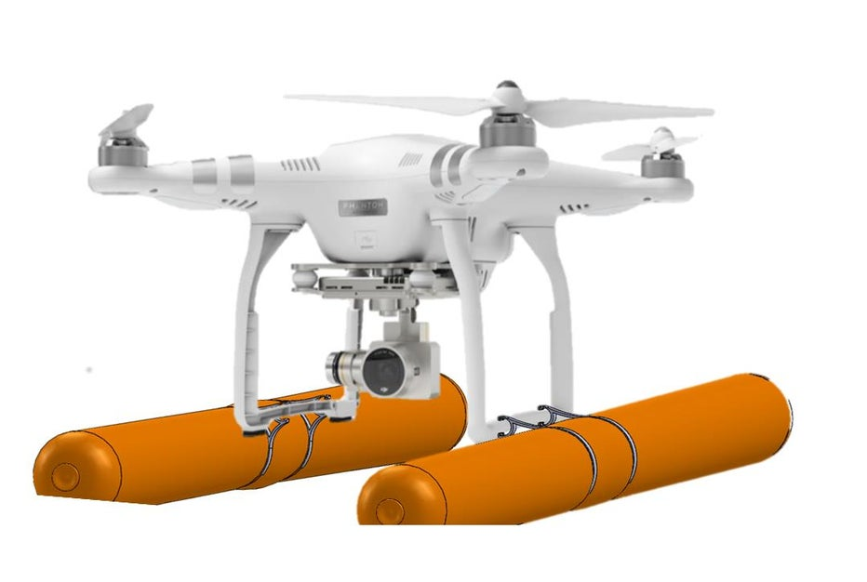
Figure 2. 350q Modeling Balloon Outrigging

- Solid Core Foam Tubes: This alternative would consist of four solid core foam tubes cut to a length of 3 in. each. Each segment would be attached under the four DC motors of the UAV providing 7.5 lb of buoyant force at a weight of 0.5 lb. This solution would cost ~$3 and allow for adjustable height that can be changed to supplement placement of electronics.

Rationale for Selecting a specific solution:

A summary of the analyses above is presented below

 | Buoyant Force | Weight | Cost | Obstruct Landing on ASV?
Water Strider | 6.6 lb | 0.57 lb | $119 | Possibly
Modelling Balloons | 26.5 lb | 0.2 lb | $2 | Yes
Foam Tubes | 7.5 lb | 0.5 lb | $3 | No
Table 1. Summary of Alternatives Analysis

While the table above appears to show the modelling balloons as the most fitting alternative, the fact that the system will interfere with landing on the ASV presents too many complications. The Water Strider offers the convenience of being a tested product with reliable reviews and user-guides; however, the cost of $119 is cause for concern. In the future, this UAV system could be produced in mass, meaning that the $119 price could become thousands or millions of dollars. Additionally, the UAV will cost ~$1000 in total, and it is recommended that a 10% increase in price is not worth a reliable flotation system. The foam tubes lie in the middle of all three categories, offering sufficient buoyant force, a manageable weight addition and a relatively low cost. Additionally, the foam tubes will not be placed on the lowest point of the UAV, meaning that the system will not interfere with landing on the ASV.

It is the recommendation of this report that the most advantageous alternative is the solid core foam tubes option.

References

[1] “WaterStrider | DroneRafts | Floats and All Terrain Landing Gear for Drones.” DroneRafts, https://www.dronerafts.com/tech-specs-waterstrider. Accessed 1 Nov. 2021.

[2] “Floating Outrigging for a Drone - Instructables.” Instructables, Instructables, 21 May 2015, https://www.instructables.com/Floating-Outrigging-For-a-Drone/.

